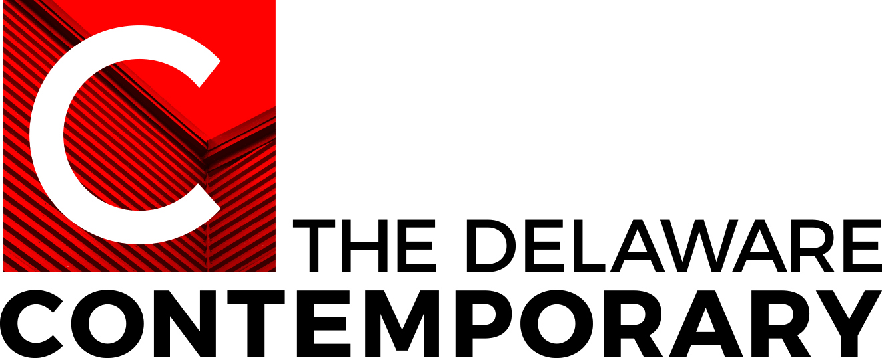
FIELDS AND FORMATIONS
A Survey of Mid-Atlantic Abstraction
Organized by The Delaware Contemporary

FEATURED ARTISTS
Natessa Amin (Philadelphia)
Arden Bendler Browning (Philadelphia)
Carol Brown Goldberg (Washington, DC)
Alex Ebstein (Baltimore)
Alex Granwell (Philadelphia)
Jesse Harrod (Philadelphia)
Maren Hassinger (Baltimore/New York)
Jae Ko (Washington, DC)
Linling Lu (Baltimore)
linn meyers (Washington, DC)
Maggie Michael (Washington, DC)
Jo Smail (Baltimore)

CURATOR
Kristen Hileman, Independent Curator and Curator-in-Residence, The Delaware Contemporary

SCHEDULE
The Delaware Contemporary, Wilmington, DE
September 3, 2021 – January 7, 2022

The American University Museum at the Katzen Art Center, Washington, DC
January 29, 2022 – May 22, 2022

PUBLICATION
Illustrated catalogue, designed by Glenn Dellon, with essays by Kristen Hileman and Philadelphia-based art historian and curator Jennie Hirsh to be published in conjunction with the exhibition

OVERVIEW
Inspired by the work of influential, yet until recently under-recognized, Washington DC-based abstractionists Alma Thomas (1891-1978) and Anne Truitt (1921-2004), this group show brings together approximately 70 works by women and non-binary artists from the Mid-Atlantic region whose unique practices move the abstract ethos of painter Thomas and sculptor-painter Truitt forward into the 21st century. Fields of luminous color and disciplined, contemplative approaches to building distinctive two- and three-dimensional compositions unite these artists from across generations and prompt the question of whether working in the Mid-Atlantic has contributed to a resonant aesthetic that significantly expands the field painting associated with such male artists as Morris Louis (1912-1962) and Kenneth Noland (1924-2010) who have come to define the mid-20th-century Washington Color School.

The exhibition offers an opportunity to celebrate creativity that has developed outside the American art capitals of New York and Los Angeles, along with the powerful ways in which abstract, formal explorations can contain referential and emotional content. The project and artists involved foreground the ideas of materiality, beauty, perseverance, community, and affect—concepts that propel art past relatively short-lived movements and trends to profoundly touch audiences inside and outside the art world. The exhibition is timed to launch in 2021, a year that will see a major re-evaluation of women in abstraction organized by Christine Macel and Karolina Lewandowska for the Centre Pompidou in Paris and traveling to the Guggenheim Bilbao, as well as a traveling retrospective of the works of Alma Thomas, organized by Jonathan Frederick Walz and Seth Feman for The Columbus Museum, Columbus, GA and the Chrysler Museum, Norfolk, VA, with additional presentations at The Frist Art Museum, Nashville, TN (in 2022), and The Phillips Collection, Washington, DC (in 2021).

The Delaware Contemporary’s inaugural Curator-in-Residence, Kristen Hileman, has grounded Fields and Formations in the extensive research that she completed on Anne Truitt, scholarship that led to her ground-breaking 2009 retrospective Anne Truitt: Perception and Reflection at the Smithsonian Institution’s Hirshhorn Museum and Sculpture Garden and its accompanying monograph. A curator working in Washington, DC and Baltimore for over twenty-five years, Hileman has followed the career development of several of the Fields and Formations artists for decades. For some, like Maren Hassinger and Jo Smail, she has already organized monographic surveys at The Baltimore Museum of Art. This unique, in-depth perspective informs the exhibition’s examination of artists who have dedicated their lives to the formal and metaphorical possibilities of vibrant color and meditative form.

